Case Study
Syntrix Biosystems ̶ SuperNova
Syntrix Biosystems designed the cutting-edge SNLS 2200 Light Activation System™ (sold under the SuperNova Life Sciences brand), a high-performance, high-throughput instrument for conducting advanced experiments with various model micro-organisms. The system gives users spatial and temporal control of protein and gene activation using different light conditions and wavelengths. The system’s target users are biologists, who need an intuitive interface that lets them focus on their experiments, not on the instrument or its software.

The system is designed to work with an off-the-shelf laboratory microscope, and incorporates multiple integrated components including:
• High-precision optics
• Programmatically controlled light sources of various wavelengths
• Digital micromirror device (DMD) for projecting precisely patterned light onto specimens
• National Instruments data acquisition system
• Lumenera scientific still/video digital camera
• Trinamic three-axis motion control system for automated stage movement and focusing
• Additional custom circuitry that was evolving during software development

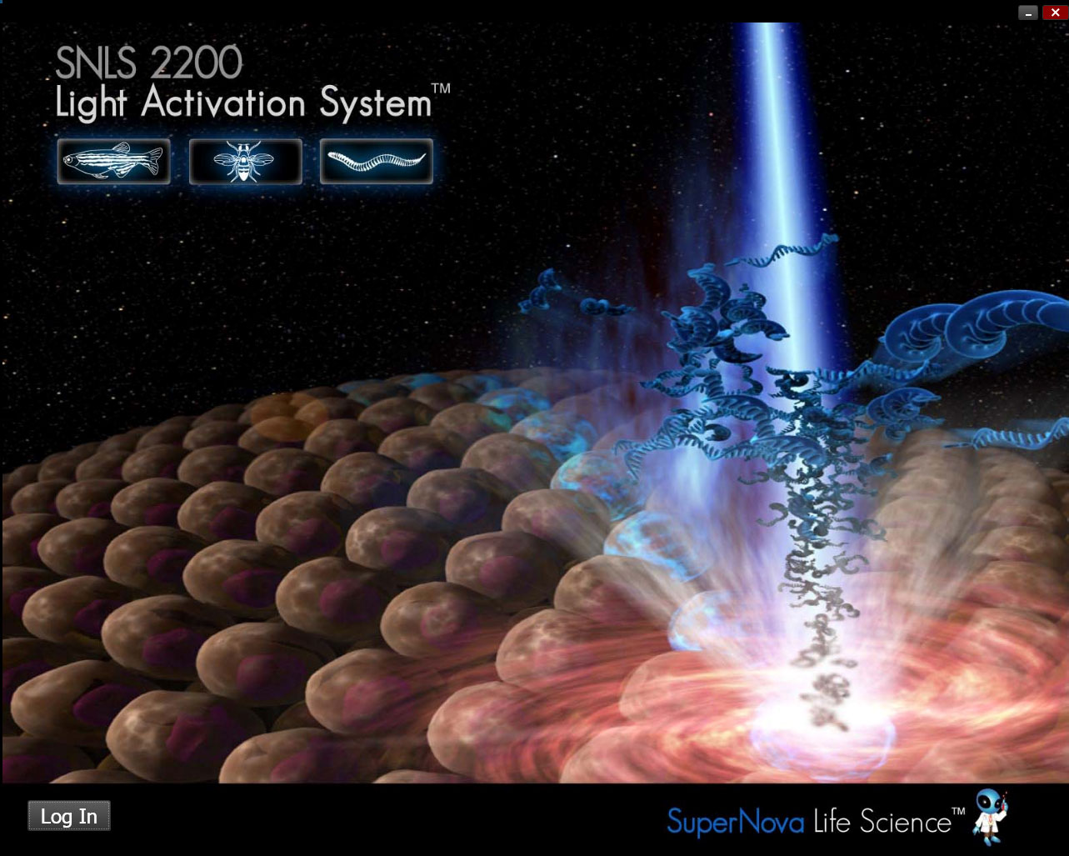
Syntrix was drawn to Jetstream Software’s end-to-end design and development skills, and engaged the company to create an application that could control the hardware and provide both functional precision and visual sophistication.

Jetstream and Syntrix followed an iterative design process, in which Jetstream engineers worked directly with executives and scientists, who were not software experts, to realize and perfect the final design by hands-on experimentation with the evolving software.

During the project, Jetstream had limited access to the prototype hardware and had to devise techniques to do much of the development work and modeling on regular PCs.

It was a high priority for Syntrix that the software provide a visually compelling user interface, and the company cited a particular commercial application as a model to be emulated. Jetstream’s UI design experts quickly prototyped an interface based on Windows Presentation Foundation (WPF) with a custom theme. This prototype became the application as functionality from the existing application was integrated with it, and new functionality was developed.

The final application Jetstream delivered included:
- The ability to manage arbitrary sets of wells on a microtiter plate and to create for each set an arbitrary sequence of light activation and image capture steps
- Validation logic that instantly determines whether a given exposure plan can be carried out without conflicts
- Application-specific WPF controls
- Multi-monitor awareness for managing the DMD display device alongside the conventional PC display
- GDI+ code for drawing masks and creating user interface elements on the DMD with pixel-perfect precision
- XML persistence of several kinds of data
- Image processing for rapid, reliable auto-focusing of the DMD on the specimen
- Multi-threaded exposure processing and autofocus routines

Jetstream also created a low-level test application to validate the functionality of the system’s custom interface board when it was completed.
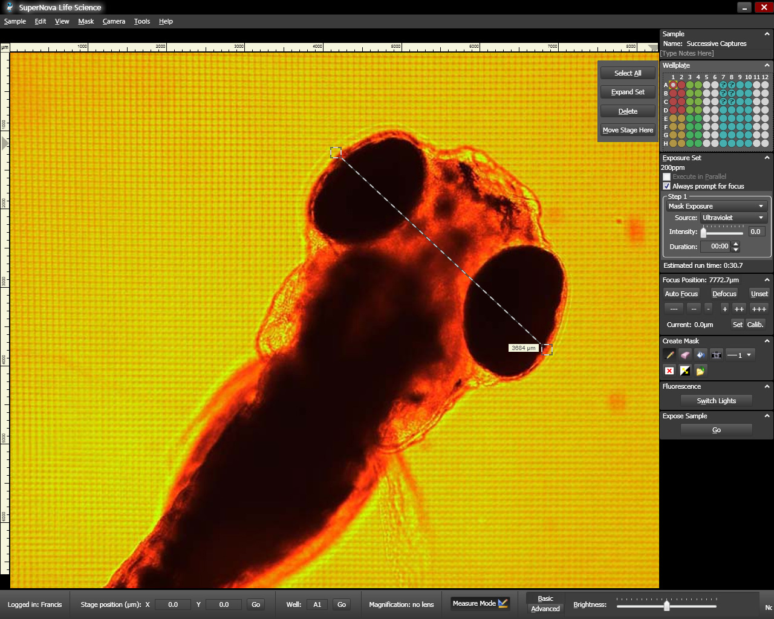
The image at left shows a Zebrafish micro-organism, and demonstrates the software’s on-screen measurement tool.

